CHAPTER 1
The Living World
• The Living World

Unit 1 | Diversity in the Living World - Unit Introduction

Biology is the science of life forms and living processes. The living world comprises an amazing diversity of living organisms.
• Early man could easily perceive the difference between inanimate matter and living organisms. He deified some of the inanimate matter (wind, sea, fire etc.) and some among the animals and plants; the common feature of all such inanimate and animate objects was the sense of awe or fear that they evoked.
• Description of living organisms, including human beings, began much later in human history. Societies with an anthropocentric view of biology could register only limited progress in biological knowledge.
• Systematic and monumental description of life forms brought in, out of necessity, detailed systems of identification, nomenclature and classification.
• The biggest spin off of such studies was recognising that similarities are shared among living organisms both horizontally and vertically.
• That all present day living organisms are related to each other, and also to all organisms that ever lived on this earth, was a revelation that humbled man and led to cultural movements for conservation of biodiversity.
• This unit describes animals and plants, including their classification, from a taxonomist's perspective: Chapter 1 The Living World, Chapter 2 Biological Classification, Chapter 3 Plant Kingdom, Chapter 4 Animal Kingdom.
Profile | Ernst Mayr (1904 - 2004)

Item | Detail
Born | 5 July 1904, in Kempten, Germany
Died | 2004, at the age of 100
Position | Harvard University evolutionary biologist; joined Harvard's Faculty of Arts and Sciences in 1953, retired in 1975, assuming the title Alexander Agassiz Professor of Zoology Emeritus
Called | 'The Darwin of the 20th century'; one of the 100 greatest scientists of all time
Career span | Nearly 80-year career; research spanned ornithology, taxonomy, zoogeography, evolution, systematics, and the history and philosophy of biology
Credited with | Almost single-handedly making the origin of species diversity the central question of evolutionary biology that it is today; pioneering the currently accepted definition of a biological species
Triple crown of biology | Balzan Prize (1983), International Prize for Biology (1994), Crafoord Prize (1999)

1.0 | What Indeed is Life? - The Question Behind the Chapter

The wide range of living types is amazing. Organisms occupy extraordinary habitats - cold mountains, deciduous forests, oceans, fresh water lakes, deserts or hot springs. The beauty of a galloping horse, of the migrating birds, the valley of flowers or the attacking shark evokes awe and a deep sense of wonder. So does ecological conflict and cooperation among members of a population and among populations of a community, and even the molecular traffic inside a cell.
The very range of organisms - in terms of size, colour, habitat, physiological and morphological features - makes us seek the defining characteristics of living organisms. The question 'what indeed is life?' carries two implicit questions:
1 | The technical question - what is living, as opposed to the non-living? Science answers this one.
2 | The philosophical question - what is the purpose of life? As scientists, we shall not attempt answering the second question.

1.1 | Diversity in the Living World

Look around and you see a large variety of living organisms - potted plants, insects, birds, your pets, other animals and plants. Several organisms cannot be seen with the naked eye, yet they are all around you. Increase the area you observe and the range and variety of organisms increases; visit a dense forest and you would probably see a much greater number and kinds of living organisms.
• Species - each different kind of plant, animal or organism that you see represents a species.
• Biodiversity - the number and types of organisms present on earth. The number of species that are known and described range between 1.7-1.8 million.
• Millions of plants and animals have been identified and described, but a large number still remains unknown - as we explore new areas, and even old ones, new organisms are continuously being identified.
• Taxonomic studies of various species of plants and animals are useful in agriculture, forestry, industry, and in general for knowing our bio-resources and their diversity.
1.1 | Nomenclature and Identification - Why Local Names Fail

We know the plants and animals in our own area by their local names, and these vary from place to place, even within a country - which is exactly the confusion that makes talking about an organism impossible. Hence naming must be standardised so that a particular organism is known by the same name all over the world.
• Nomenclature - the process of standardising the naming of living organisms. It is only possible when the organism is described correctly and we know to what organism the name is attached.
• Identification - describing the organism correctly and knowing which organism a name belongs to. Identification must therefore come before naming.
A number of scientists have established procedures to assign a scientific name to each known organism, acceptable to biologists all over the world:
Code | Full form | Applies to
ICBN | International Code for Botanical Nomenclature - scientific names based on agreed principles and criteria | Plants
ICZN | International Code of Zoological Nomenclature - evolved by animal taxonomists | Animals

• Scientific names ensure that each organism has only one name.
• A description of any organism should enable people in any part of the world to arrive at the same name.
• They also ensure that such a name has not been used for any other known organism.
1.1 | Binomial Nomenclature

Biologists follow universally accepted principles to provide scientific names. Each name has two components - the Generic name and the specific epithet. This system of providing a name with two components is called Binomial nomenclature, given by Carolus Linnaeus and practised by biologists all over the world; the two word format was found convenient.
Worked example - the scientific name of mango is Mangifera indica: Mangifera represents the genus, while indica is a particular species, or a specific epithet.
Rule | What it says | Illustration
1. Language | Biological names are generally in Latin and written in italics. They are Latinised or derived from Latin irrespective of their origin. | Mangifera indica
2. Order of words | The first word represents the genus; the second component denotes the specific epithet. | Mangifera = genus, indica = specific epithet
3. Handwriting vs print | Both words, when handwritten, are separately underlined; when printed they are in italics - to indicate their Latin origin. | <u>Mangifera</u> <u>indica</u>
4. Capitalisation | The first word denoting the genus starts with a capital letter; the specific epithet starts with a small letter. | Mangifera indica (not Mangifera Indica)
5. Author citation | The name of the author appears after the specific epithet, i.e. at the end of the biological name, in an abbreviated form. It indicates who first described the species. | Mangifera indica Linn. - first described by Linnaeus

1.1 | Classification, Taxonomy and Systematics

Since it is nearly impossible to study all the living organisms, some means is necessary to make the study possible - this process is classification.
• Classification - the process by which anything is grouped into convenient categories based on some easily observable characters.
We easily recognise groups such as plants, animals, dogs, cats or insects, and the moment we use such a term we associate certain characters with the organism in that group: think of 'dogs' and you see dogs, not cats; think of 'Alsatians' and you know exactly what is meant; say 'mammals' and you think of animals with external ears and body hair; say 'Wheat' and you picture wheat plants, not rice.
• Taxa - the scientific term for such convenient categories. Taxa can indicate categories at very different levels: 'Plants', 'Wheat', 'animals', 'mammals' and 'dogs' are all taxa - yet a dog is a mammal and mammals are animals, so they represent taxa at different levels.
Based on characteristics, all living organisms can be classified into different taxa - and this process of classification is taxonomy. The basis of modern taxonomic studies is: external and internal structure, along with the structure of cell, development process and ecological information of organisms.
Four processes are basic to taxonomy:
1 | Characterisation - record the characters of the organism.
2 | Identification - establish which organism it is.
3 | Classification - place it in convenient categories (taxa).
4 | Nomenclature - give it its universally valid two-part name.

Taxonomy is not something new. Human beings have always been interested in knowing more about the various kinds of organisms, particularly with reference to their own use: in early days they needed sources for their basic needs of food, clothing and shelter, so the earliest classifications were based on the 'uses' of various organisms.
• Systematics - the branch of study of the relationships among different kinds of organisms, not merely of their kinds and diversities. The word is derived from the Latin word 'systema', meaning systematic arrangement of organisms; Linnaeus used Systema Naturae as the title of his publication.
• The scope of systematics was later enlarged to include identification, nomenclature and classification.
• Systematics takes into account evolutionary relationships between organisms.
[NOTE] Do not blur the four terms. Identification = which organism is this? Nomenclature = what is its one valid name? Classification = grouping into taxa on easily observable characters. Taxonomy = the whole process of classifying organisms into taxa. Systematics is the widest: identification + nomenclature + classification, plus evolutionary relationships.

1.2 | Taxonomic Categories

Classification is not a single step process but involves a hierarchy of steps, in which each step represents a rank or category. Since the category is a part of the overall taxonomic arrangement, it is called the taxonomic category, and all categories together constitute the taxonomic hierarchy.
• Taxon (pl.: taxa) - each category, referred to as a unit of classification, which in fact represents a rank.
Example: insects represent a group of organisms sharing common features like three pairs of jointed legs. That makes insects recognisable concrete objects which can be classified, and thus they were given a rank or category. Groups represent category; category further denotes rank; each rank or taxon represents a unit of classification.
[NOTE] These taxonomic groups/categories are distinct biological entities and not merely morphological aggregates - a favourite one-line NEET statement.

Taxonomical studies of all known organisms have led to the development of common categories: kingdom, phylum or division (for plants), class, order, family, genus and species. All organisms, including those in the plant and animal kingdoms, have species as the lowest category. To place an organism in these categories, the basic requirement is knowledge of the characters of an individual or group of organisms - this helps in identifying similarities and dissimilarities among individuals of the same kind of organisms as well as of other kinds.
1.2.1 | Species

Taxonomic studies consider a group of individual organisms with fundamental similarities as a species. One should be able to distinguish one species from the other closely related species based on the distinct morphological differences.
• In Mangifera indica, Solanum tuberosum (potato) and Panthera leo (lion), the names indica, tuberosum and leo represent the specific epithets, while the first words Mangifera, Solanum and Panthera are genera and represent another higher level of taxon or category.
• Each genus may have one or more than one specific epithets representing different organisms, but having morphological similarities: Panthera has another specific epithet called tigris, and Solanum includes species like nigrum and melongena.
• Human beings belong to the species sapiens, grouped in the genus Homo - so the scientific name for human being is Homo sapiens.
1.2.2 | Genus

Genus comprises a group of related species which has more characters in common in comparison to species of other genera; genera are aggregates of closely related species.
• Potato and brinjal are two different species but both belong to the genus Solanum.
• Lion (Panthera leo), leopard (P. pardus) and tiger (P. tigris), with several common features, are all species of the genus Panthera. This genus differs from another genus Felis, which includes cats.
1.2.3 | Family

Family, the next category, has a group of related genera with still less number of similarities as compared to genus and species. Families are characterised on the basis of both vegetative and reproductive features of plant species.
Kingdom side | Genera placed together | Family
Plants | Solanum, Petunia, Datura (three different genera) | Solanaceae
Animals | Panthera (lion, tiger, leopard) put along with Felis (cats) | Felidae
Animals | The dog line - observe a cat and a dog and you find some similarities and some differences as well, so they are separated into two different families | Canidae (dog) vs Felidae (cat)

1.2.4 | Order

Categories like species, genus and families are based on a number of similar characters. Generally, order and other higher taxonomic categories are identified based on the aggregates of characters.
• Order, being a higher category, is the assemblage of families which exhibit a few similar characters; these similar characters are less in number as compared to different genera included in a family.
• Plants: families like Convolvulaceae and Solanaceae are included in the order Polymoniales, mainly based on the floral characters.
• Animals: the order Carnivora includes families like Felidae and Canidae.
1.2.5 | Class

This category includes related orders. For example, order Primata comprising monkey, gorilla and gibbon is placed in class Mammalia, along with order Carnivora that includes animals like tiger, cat and dog. Class Mammalia has other orders also.
1.2.6 | Phylum (Division in plants)

Classes comprising animals like fishes, amphibians, reptiles, birds along with mammals constitute the next higher category called Phylum. All these, based on the common features like presence of notochord and dorsal hollow neural system, are included in phylum Chordata. In case of plants, classes with a few similar characters are assigned to a higher category called Division.
1.2.7 | Kingdom

All animals belonging to various phyla are assigned to the highest category called Kingdom Animalia in the classification system of animals. The Kingdom Plantae, on the other hand, is distinct, and comprises all plants from various divisions. Henceforth these two groups are referred to as animal and plant kingdoms.
The taxonomic categories from species to kingdom in ascending order, starting with species, are: Species, Genus, Family, Order, Class, Phylum or Division, Kingdom. These are broad categories; taxonomists have also developed sub-categories in this hierarchy to facilitate more sound and scientific placement of various taxa.
Rank (ascending) | What it groups | Chapter example
Kingdom | The highest category; all phyla of animals, all divisions of plants | Kingdom Animalia; Kingdom Plantae
Phylum or Division | Phylum - classes of animals with common features; Division - plant classes with a few similar characters | Chordata (notochord, dorsal hollow neural system); Angiospermae
Class | Related orders | Mammalia (has other orders also); Insecta
Order | Assemblage of families exhibiting a few similar characters | Carnivora; Polymoniales; Primata
Family | Related genera, with still less number of similarities | Felidae; Canidae; Solanaceae
Genus | Aggregate of closely related species | Panthera; Solanum
Species | The lowest category; individuals with fundamental similarities | Panthera leo; Homo sapiens

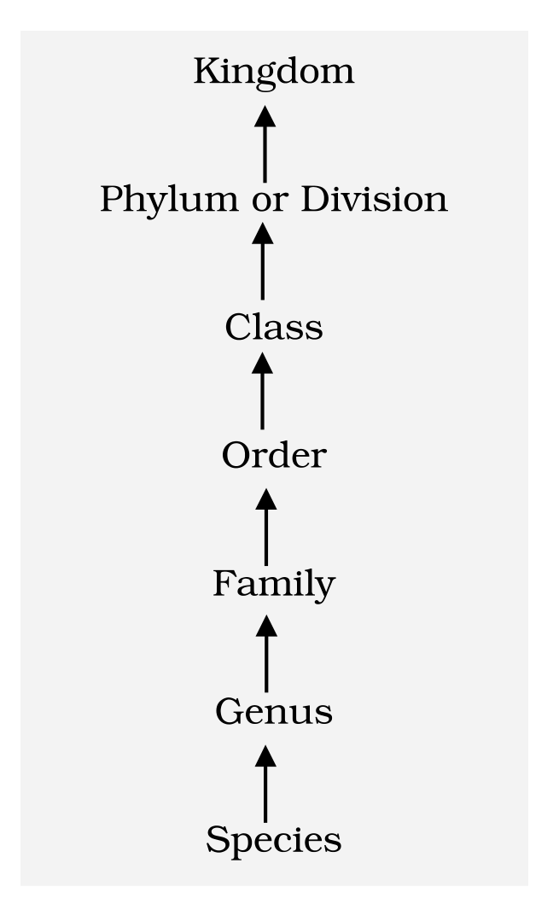
Fig. 1.1 - Taxonomic categories showing hierarchial arrangement in ascending order.
Reading the hierarchy tells you the basis of arrangement:
• As we go higher from species to kingdom, the number of common characteristics goes on decreasing.
• Lower the taxa, more are the characteristics that the members within the taxon share.
• Higher the category, greater is the difficulty of determining the relationship to other taxa at the same level - hence the problem of classification becomes more complex.
[MEMORY AID - not in NCERT] Ascending order Species to Kingdom: Some Girls Find Our Class Pretty Kind - Species, Genus, Family, Order, Class, Phylum, Kingdom. Read it backwards for descending order.

Table 1.1 | Organisms with their Taxonomic Categories

Table 1.1 indicates the taxonomic categories to which some common organisms like housefly, man, mango and wheat belong.
Common Name | Biological Name | Genus | Family | Order | Class | Phylum/Division
Man | Homo sapiens | Homo | Hominidae | Primata | Mammalia | Chordata
Housefly | Musca domestica | Musca | Muscidae | Diptera | Insecta | Arthropoda
Mango | Mangifera indica | Mangifera | Anacardiaceae | Sapindales | Dicotyledonae | Angiospermae
Wheat | Triticum aestivum | Triticum | Poaceae | Poales | Monocotyledonae | Angiospermae

[NOTE] Read Table 1.1 column-wise for the two plant entries: mango is Dicotyledonae and wheat is Monocotyledonae, yet both are Angiospermae - the class differs while the division is the same.

Recap | Quick Recap

• The living world is rich in variety. Millions of plants and animals have been identified and described, but a large number still remains unknown. The range of organisms in size, colour, habitat, physiological and morphological features is what makes us seek the defining characteristics of living organisms. Known and described species: 1.7-1.8 million.
• To facilitate the study of kinds and diversity of organisms, biologists evolved rules and principles for identification, nomenclature and classification; the branch of knowledge dealing with these aspects is taxonomy.
• The basics of taxonomy - identification, naming and classification - are universally evolved under international codes: ICBN for plants, ICZN for animals.
• Based on resemblances and distinct differences, each organism is identified and assigned a correct scientific/biological name comprising two words as per the binomial system of nomenclature (Carolus Linnaeus): capitalised genus, small-letter specific epithet, Latin, italics in print and separately underlined when handwritten, with the abbreviated author name at the end.
• An organism occupies a place or position in the system of classification. There are many categories/ranks, generally referred to as taxonomic categories or taxa, and all the categories constitute a taxonomic hierarchy - species (lowest) to kingdom (highest).
• Taxonomic studies of species of plants and animals are useful in agriculture, forestry, industry and for knowing our bio-resources and their diversity. Systematics adds evolutionary relationships to identification, nomenclature and classification.
Appendix | Terms Used in the Exercises

These exercise questions lean on points the chapter body assumes rather than states outright. Each answer below is assembled only from facts stated in this chapter.
• Why classification systems keep changing (Q2). Three chapter facts explain it: (i) as we explore new areas, and even old ones, new organisms are continuously being identified, so the arrangement must accommodate them; (ii) taxonomists keep developing sub-categories in the hierarchy to facilitate more sound and scientific placement of various taxa; (iii) systematics takes evolutionary relationships into account, and the basis of modern taxonomic studies includes internal structure, cell structure, development process and ecological information - as this evidence improves, the grouping is revised.
• What identification of individuals and populations gives us (Q4). Identification is what makes nomenclature possible at all - a name can be attached only to a correctly described organism. It yields a single universally valid name per organism, so that a description lets people in any part of the world arrive at the same name and no name is reused for another known organism; and it is how the count of known and described species (1.7-1.8 million), i.e. our record of biodiversity, is built.
• The meaning of 'species' (Q8). In this chapter, a species is a group of individual organisms with fundamental similarities, distinguishable from closely related species by distinct morphological differences - a morphological criterion. The unit profile adds that Ernst Mayr pioneered the currently accepted definition of a biological species. For higher plants and animals these criteria work well; for bacteria this chapter supplies no criterion at all, so that part of the question is deliberately left to discussion with your teacher rather than answered from outside sources.
• Answer keys the chapter fixes directly. Q5 - the correctly written name is Mangifera indica (genus capitalised, specific epithet in small letters). Q7 - the correct sequence is Species, Genus, Order, Phylum, i.e. option (c), because the ascending order is Species, Genus, Family, Order, Class, Phylum or Division, Kingdom. Q6 - a taxon is a unit of classification representing a rank, e.g. Homo (genus), Hominidae (family), Primata (order), Mammalia (class), Chordata (phylum).

